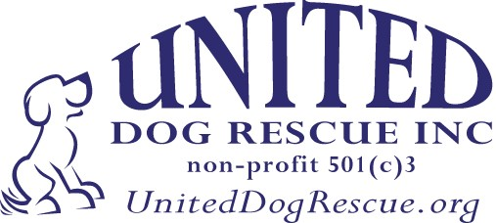
UNITED DOG RESCUE, INC.
331 East Commercial Blvd, Oakland Park, FL. 33338

DOG ADOPTION APPLICATION

  - Completing an application does not guarantee adoption approval, nor does it obligate you to adopt. Some dogs have special needs. Not all dogs are suitable for all homes.
  - All applications are screened, which may include a home visit.
  - There is a donation required in order to adopt from United Dog Rescue, Inc.

Name of the dog applying for: _________________________ Date: ___________________________

First Name: _____________________________ Last Name: ________________________________ Age: __________

Relationship Status: __________________ Partner’s Name: __________________________________ Age: __________

Home Phone: __________________ Mobile Phone: ________________ Email: __________________________________

Street Address: _________________________________City: _____________________ State: _______ Zip: __________

Occupation: ____________________________ How many hours each day are you away from home? _______________

Housing Information (circle one). Single Family Apartment Townhouse/Condo Mobile Home

Do you rent or own? ______________________ If you rent, do you have your landlord’s permission? _______________

How long have you lived at this address? ___________

Are there any dog breed or size restrictions at your residence and if so, what are they? ___________________________

If renting, please provide the landlord’s name and contact information. _______________________________________

Do you have a fenced yard? __________ How tall is it? _________________ Do you have a doggie door? ___________

Where will your dog be during the day? _________________________________________________________________

Will the dog be left alone outside, and if so, how long? ________. Where will the dog sleep? ______________________

How many people live in your home? _____________ Their ages? ____________________________________________

Do you have many visitors? ________________________________ Do children visit? ___________________________

Other animals in your home

Do you have other dogs? _________________________ How many? ________ Are they neutered? ________

Are they current on vaccines? ________________ Do you use heartworm prevention? ____________________

Do you have any other pets? _________________ Are they neutered and current on vaccines? _____________

Have you had dogs in the past? _________________ If so, what breed? ________________

What happened to the dogs? ___________________________________________________________________

Veterinary Care

Do you have a regular veterinarian? _______________________ If so, who? _____________________________

What do you consider to be reasonable ROUTINE veterinary care expenses YEARLY? ______________________

Do you agree that the information you have given in the above application is true, and that if any information is
found to be false United Dog Rescue, Inc. will have the right to reclaim the adopted pet? ___________________

Do you understand that there is an adoption donation to United Dog Rescue and that this will be used for the rescue and care of other dogs for other dogs? __________________________

____________________________________ ___________________________________ _____________
SIGNATURE PRINTED NAME DATE

